**Fees and Charges**

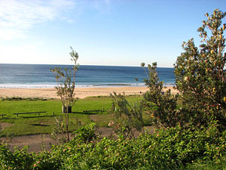These fees cover 2 persons. Additional persons (exception children under 8 years)are charged per the schedule of fee's. A maximum of 6 persons may occupy the same site.

Payment of the total period of stay must be made on or prior to arrival

|  | **Off Season** (2 person basis) | | | **On Season** (2 person basis) | | |
| --- | --- | --- | --- | --- | --- | --- |
| **Site Rates are inclusive of 2 persons** | **Nightly** | **Weekend** (2 night minimum booking-Fri/Sat) rate per night | **Weekly** | | **Nightly** | **Weekly** |
| Powered sites – including one car and/or caravan/trailer/tent | $30 | $36 | $192 | | $45 | $315 |
| Powered sites – approved senior card holder (not available in on season & school holidays) | $25 | $30 | $160 | | n/a | n/a |
| Unpowered sites – including one car and/or caravan/trailer/tent | $25 | $30 | $160 | | $38 | $266 |
| Unpowered sites – approved senior card holder (not available in on season & school holidays) | $20 | $25 | $130 | | n/a | n/a |

**Extra charges**

**Weekly & Seniors discounts are not available in the On Season and School Holidays.**

|  |  |
| --- | --- |
| Extra persons (8-17years) & non immediate family members under 8 years | $12 mid; week $15 w/end & "on season"- nightly; $80 weekly -off season only. |
| Extra persons (18years and over) | $12 mid; week $15 w/end & "on season"- nightly; $80 weekly -off season only | |
| Late check out to 3:00pm (conditions apply) | 50% of daily rate | |
| Late check out after 3:00pm (conditions apply) | Full nightly rate | |
| **Cancellation fee –** | **Full Deposit** | |
| **Group bookings - see manager regarding rates.    Fees for non-immediate family extras will apply to under 8 year olds** |  | |
|  | | |

The Schedule of Fees & Charges is a guide only - Management discretion applies & Fees & Conditions may be altered without notice